Service and Manufacturing (two key differences) 1. The nature of their output and the degree of customer contact.
How process work: Input to process and operation to output to internal/external customer
Internal customer: employee whose input is the output of earlier process in the firm. Internal supplier : employee who supply material or information
Nested process: the process can be separated into many subprocesses
Core process: deliver value to external customer support process: provide vital resource and inputs into core process
core competency: unique resource or strength of a company. Market analysis: divide customer into segments and identify needs of each segment.
Supply chain process: business process that have external supplier or customer( outsourcing, warehousing)
Corporate strategy: overall direction for carrying firms’ function, the business it will pursue
Competitive priorities: a process that a firm must have for customers
- Competitive capability : The cost, quality, time, and flexibility dimensions that a process or supply chain actually possesses and is able to deliver.
Internet of things: the interconnectivity of objects that allow them to exchange data themselves without human.
- SIPOC: supplier, input, Process, output, Customer
- 3 principles: make decisions that fit situation better, cumulative effect of customer satisfactions. Interfaces between process
- 4 decision: process structure, customer involvement, resource flexibility, capital intensity
- customer-contact Matrix 横（volume）竖（variety ) service process structuring: front-office, hybrid office,back office
- Product-Process Matrix 横（volume） process characteristics（product customization， Process characteristics）
- Job Process: Low Volume , High Flexibility/ Customizability, None/ Low automation, Ease/ Inexpensive Capacity Change. Make products to order and do not produce them ahead of time.
- Batch Process: Moderate Volume per Product, Moderate flexibility/ Customizability, Simple automation, Moderate Ease/ Expense Capacity Change
- Line Process: High Volume, Low flexibility, High automation, Difficult/ Expensive Capacity Change. Standard products are produced in advance of their need and held in inventory so that they are ready when a customer places an order. i.e. 电脑，玩具，汽车组装
- Continuous-Flow Process: extreme high-volume standardized, material moves without stopping through the process. (e.g petroleum refining; chemical processes; paper manufacturing…)
- Design-to-Order: Design new products that do not currently exist, and then manufacture them to meet unique customer specifications. (e.g. A designer pair of shoes for a particular client) Job process
- Make-to-Order: Manufacturers that make products to customer specifications in low volumes. (e.g. Specialized medical equipment, castings, and expensive homes) Job/ small batch process
- Assemble-to-Order: Producing a wide variety of products from relatively few subassemblies and components after the customer orders are received. a line process for assembly and a batch process for fabrication
- Make-to-Stock: immediate delivery, minimizing customer delivery times.(e.g. garden tools, electronic components, soft drinks, and chemicals) line or continuous-flow processes
- Process improvement: understand the fact, dig the detail, then improve
- Process analysis: understand how work is performed and how it can be redesigned.
- Benchmarking （标杆分析法 - 与其他公司进行比较）: systematic procedure that measures a firm’s processes, services, and products against those of industry leaders. Competitive: comparison with a direct industry competitor. Functional: compares certain areas with those of outstanding firms in any industry. Internal: compare with internal organizational units with superior performance
Chapter 3
- Prevention cost. Appraisal Cost.(Test) Internal failure cost.(Not sale it, replace it) External failure cost. (Customer discover) Ethical
- Appraisal鉴定 cost: Prevention增加，这个减少 3. Internal/external failure costs 4. Ethical failure cost(4 大cost)
- TQM (customer satisfaction: conformance to specifications, value,fitness for use, support, psychological impressions) (Employee Involvement: Problem-solving tools, service/product design) (Continuous improvement: process design, purchasing)
- Six sigma: achieve business success by minimizing defects and variables in system
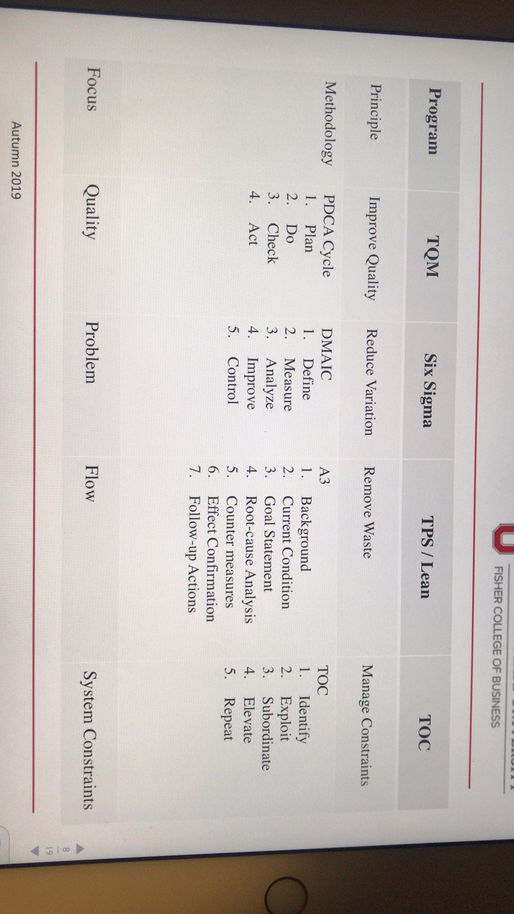
- Perato chart contains both line and bars graph
- Cause and effect diagram: Machines, manpower, method, material, other
- Purpose of Statistical Process Control (SPC)Methodology for monitoring a process to identify special causes of variation and signals the need to take corrective action when it is appropriate
- Attributive data(qualitative) Variable data(quantitative)
- Common cause(noise): is present in every process. When only exist, it’s stable, predictable and in-control
- Special cause: unpredictable, large in comparison to Common cause. Can be removed/ lessened by basic control(employee need training, machine need repair
- P-chart p+-3厂(P(1-p)/n) X-bar chart x+- A2R R-chart LCL = D3R UCL = D4R
Productivity = output/input Multifactor ratio = out/labor + material +overhead labor ratio = output/ labor
- Control chart: to see if any number is abnormal R-chart if any number is out of the line, it’s uncontrolled
X-chart: whether the process is generating output, on average, consistent with a target value set by management for the process or whether its current performance, with respect to the average of the performance measure, is consistent with its past performance
P-chart: A chart used for controlling the proportion of defective services or products generated by the process.
Malcolm Baldridge: raise awareness of quality management and recognize U.S. companies that have implemented successful quality management systems.
Systems approach to TQM